KENDRIYA VIDYALAYA NO. 2, ANGUL
HOLIDAY HOMEWORK
DURGA PUJA VACATION
CLASS 6
DATE | SUBJECT:-MATH
20.10.2023 | Write Multiplication table from 11-25 in your homework copy and learn it and recite it to your parent(s). Write and learn divisibility of 2,3,4,5,6,8,9,10 in your HOMEWORK COPY
22.10.2023 | SOLVE THESE QUESTIONS:  - Express 11/20 as a decimal.  - Express $6\frac{2}{3}$as an improper fraction.  - Express $3\frac{2}{5 }$ as a decimal.  - Add the fractions 3/8 and 2/3 .  - Add the fractions 3/8 and $6\frac{3}{4}$.  - Subtract 1/6 from 1/2 .  - Subtract $8\frac{1}{3}$ from 100/9  - Subtract $1\frac{1}{4}$ from $6\frac{1}{2}$ .  - Add $1\frac{1}{4}$and $6\frac{1}{2}$ .  - Grip size of a tennis racquet is $11\frac{9}{80}$cm. Express the size as an improper fraction.
24.10.2023 | 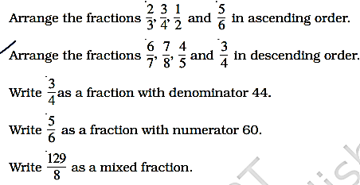
28.10.2023 | 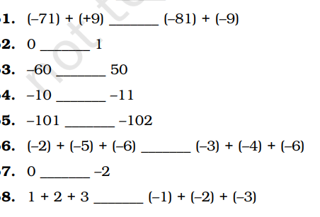  In questions 1 to 8, fill in the blanks using <,>,=:

SUBJECT:- SST
1. Write a story of Gautama Buddha.
2. Write a story of Ashoka the Great.
3. Drawing of the Biosphere.
4. On an outline map of the world mark/label the Major Mountains of the world.
(At least one mountain should be from each continent)
Note: All the above work should be done in the A4 white paper
1. Prepare MDP & Learner’s Diary.
2. Prepare Art Integrated Project on Paired State (Maharashtra).
3. Complete your notebook work.

SUBJECT:-ENGLISH
1.Write a letter to your younger brother who has grown very weak. Suggest ways how he can improve his health.
2. Write a letter to your father requesting him to buy you a cycle.
3.Write paragraphs On the following topics.
A). Importance of Trees
B) Mahatma Gandhi
4. A)You are Babble of Class 6th. While going for your sports period you had found a lunch box lying on the stairs. You have kept the lunch box to return it to whoever it belongs- Write a notice for all the students informing them about this issue.
B) You are AJain of Class 6th. Write a notice for the students of your school informing them about the water bottle that you lost during your Sports period.
5.A) You are Anurag and you forgot to inform the mother about your best friend Nikhil's birthday party. Now your mother is in the office and your phone is out of order. You want to leave a message for your mother and the keys of the house with your neighbuor. Write the message, on behalf of Anurag, also telling her that Nikhil's father will drop you home at about 9 p.m.
B) Sunil was on his way to Singapore to spend holidays with his Aunt and Uncle. At the airport, just before his plane was due to depart, he remembers that it was his grandmother's 75th birthday next week. He called up at home to tell his elder sister, Ankita, to take out the present, at home so Sunil left the message with his younger brother, Vishwas. As Vishwas write a message for Ankita.

SUBJECT:-SCIENCE
Write the answers of the following question in homework copy-
- Name the food needed:
a. for strong bones and teeth
b. to prevent scurvy
c.to avoid constipation
d.for warmth
e.for growth.
- What is roughage? Why its presence in our food is important?
- What is the need for classification?
- Why is it advised to take iodised salt?
- What do you understand by life cycle and life span of a living thing?
- What is dislocation and fracture of a bone? What precaution should one take when one gets a fracture?
- Write any four properties of materials.
- What are nodes and internodes?
- How will you Separate a mixture of common salt and chalk powder?
- What are climbers and creepers? Give some examples.
- Explain the difference between taproots and fibrous roots with the help of diagrams.
- What is the function of skeleton?
- Give three main adaptive features in desert plant.
- How is a fish adapted to live in water?
- What are the roles of
(a) carbohydrates,
(b) fats,
(c) vitamins and
(d) minerals.

SUBJECT:-HINDI
प्रश्न १-'जिन लोगों के पास आंखें हैं वे सचमुच बहुत कम देखते हैं' हेलेन केलर को ऐसा क्यों लगता था ?
प्रश्न २-'प्रकृति का जादू' किसे कहा गया है ?
प्रश्न ३-हेलेन केलर प्रकृति की किन चीजों को छूकर और सुनकर पहचान लेती थी ? पाठ के आधार पर उसका उत्तर लिखिए ?
प्रश्न ४-वाक्य किसे कहते हैं ? इसके कितने प्रकार होते हैं उदाहरण सहित लिखिए ?
प्रश्न ५-दशहरे की छुट्टियों पर अपने शब्दों में एक अनुच्छेद लिखिए ?
SUBJECT:-SANSKRIT
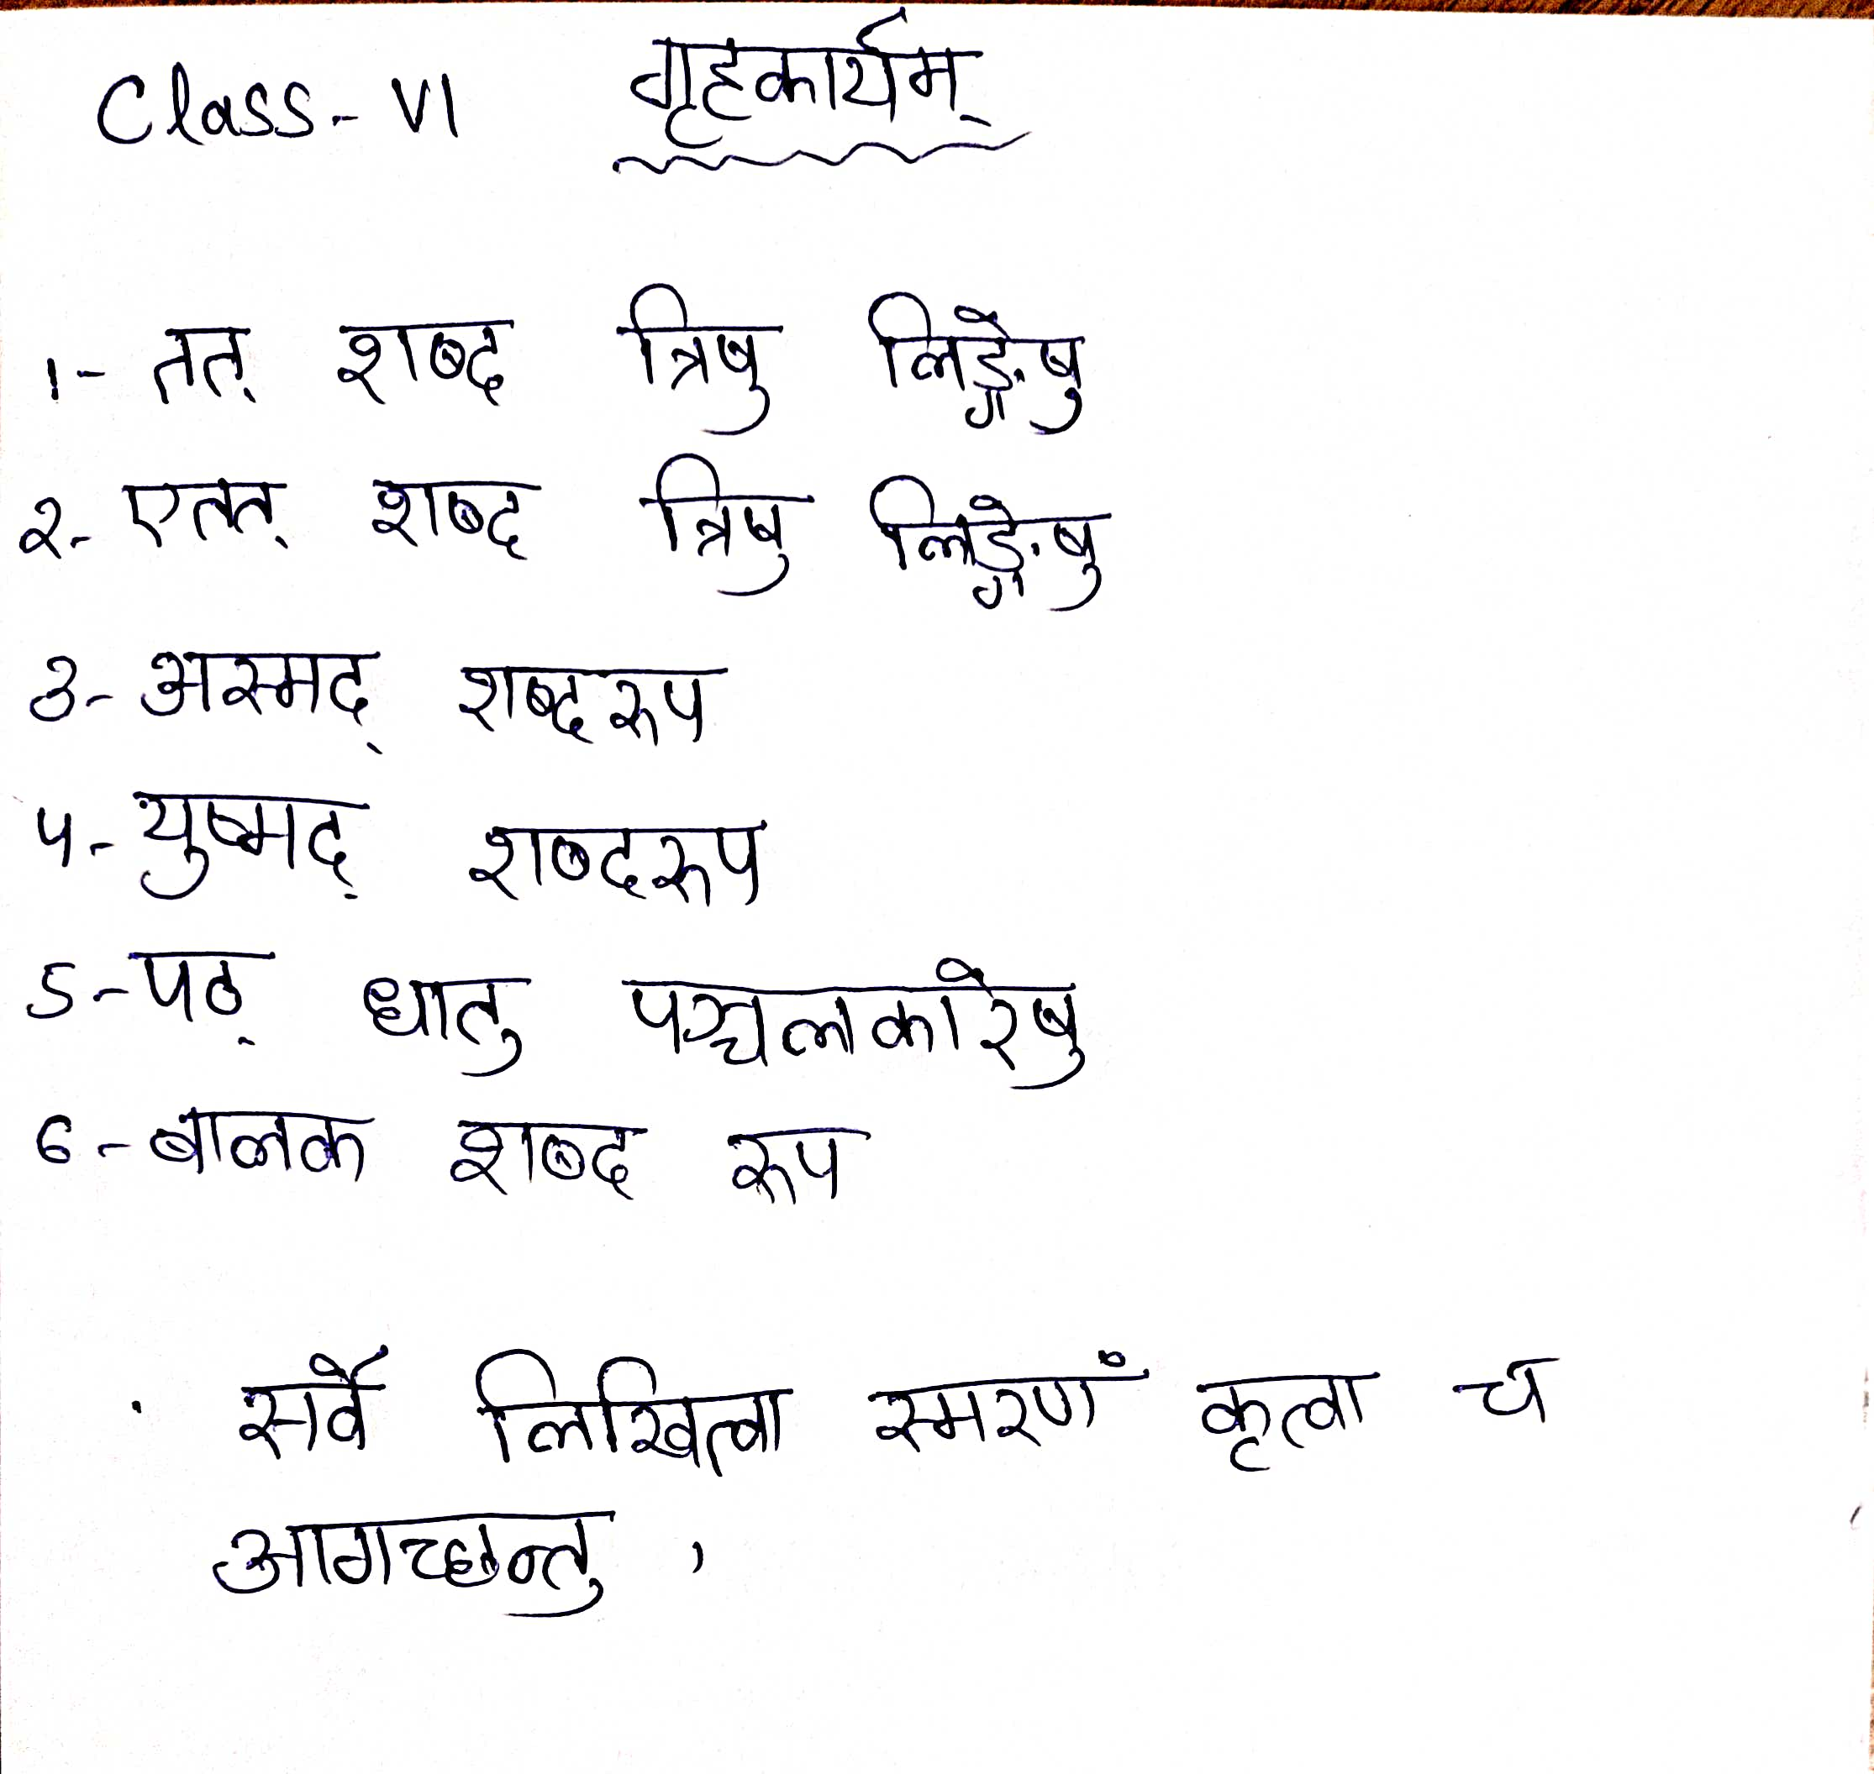
SUBJECT:-COMPUTER
- What is Multimedia? Explain components of Multimedia.
- Create a word file to show History of computer and paste the word document in your copy.
- Create a excel table to show your monthly test-I marks and calculate the full marks using formula paste it in your copy.
- Write down the steps to create a table using MS-WORD and print the table and paste it.
- Explain word art. Write your name using word art and paste it.

