Winter break homework
Class:- 6th Subject :- Science
1. Define the following terms-
A.Opaque objects B.Luminous objects C.magnetic materials D. Periodic Motion E. Magnetite F. Shadow
2. Draw the following diagram –
A. An electric circuit B. Different shapes of magnet. C. Internal Structure of Torch
3 Convert the followings-
A. 50 cm……………….mm B. 5.25 Hr ………….minutes
C. 50000m……………km D. 720 minutes …………. Hr.
4. write any two examples of conductor and non-conductors.
5. Learn the question and answer of chapter given for PT2.
6. PROJECT- Make a simple periscope.

WINTER- BREAK HOMEWORK
Subject-Science Class- VII
WRITE THE ANSWERS OF THE FOLLOWING QUESTIONS IN H.W COPY.
1 .Given below as Figure 13.8 is the distance-time graph of the motion an object.
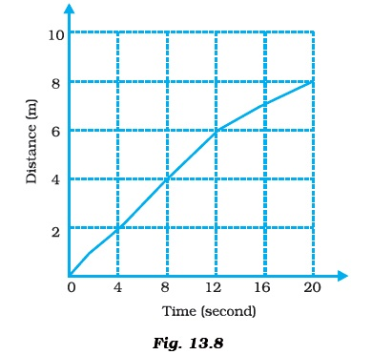
- (i) What will be the position of the object at 20s?
- (ii) What will be the distance travelled by the object in 12s?
- (iii) What is the average speed of the object?

2 .Define speed. Write its SI unit. A car travels with a speed of 40 km/h for 15
minutes and then with a speed of 60 km/h for next 15 minutes. Find the total distance covered by it.
3. Draw the distance- time graph for the motion of following cases.
i. a car moving with constant speed
ii. a car parked on a side road.
4 .Write the two effects of electric current.
5 .Draw the circuit diagram with a cell, bulb and switch a) ON position b) OFFposition
6 . Write the characteristics of image formed by the plane mirror.
7. What do you mean by (a) Fuse (b) overloading (c) Short Circuiting?
PROJECT- COLLECT NAMES AND PICTURES OF 20 MEDICINAL PLANTS AND WRITE THE FOLLOWING DETAILS OF THE PLANT-
- NAME OF THE PLANT
- SCIENTIFIC NAME OF THE PLANT
- LOCAL NAME OF THE PLANT
- ITS MEDICINAL USES.

WINTER- BREAK HOMEWORK
Subject-Science Class- VIII
1. Draw the following diagrams in H.W copy-
i. Adam's apple
ii. Position of endocrine glands in human body
iii. Voice box in humans
2. Find out the health concerns associated with chromium electroplating. How are people trying to resolve them?
4. Current does not flow in a circuit if there is a gap between the two wires. Does it indicate that air is a poor conductor of electricity? Does air never conduct electricity? Explain.
5. What are secondary sexual characters?
6. What is the role of hormones in completing the life history of insects and frogs?
7. A simple pendulum makes 20 oscillations in 40 seconds. What is the time period and frequency of its oscillation?
8. Learn the question answers of the chapters taught .
PROJECT – COLLECT PICTURES OF NATURAL DISASTERS WHICH HAVE OCCURRED IN THE RECENT YEARS IN INDIA AND WRITE ABOUT THEM.
THE PROJECT SHOULD BE WRITTEN IN A4 SIZE PAPER.

WINTER- BREAK HOMEWORK
Subject-Science Class-IX
- Complete all the lab activities in your practical copies.
- Write the answers of the following questions in your copy-
- Write two aims of poultry forming. Name one indigenous and one exotic breeds of hen.
- “Efforts are always made to improve production from agriculture and animal husbandry. Why is it necessary?
- (a) Define the term “energy”. Write the names of different forms of energy.
- (b) Define kinetic energy. Derive an expression for the kinetic energy of an object of mass m moving with a velocity V.
- State Newtons law of gravitation. Write the mathematical equation for Newton’s law of gravitation.
- When a person jumps out of a boat, the boat moves backward. Explain, why ?
- Complete the following flow diagram :
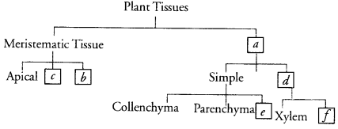

- Draw a neat diagram of an animal cell and label on it the following :
Plasma membrane. Nucleus, Lysosome/RER, centriole, Lysosome.
- List three observations of the experiment performed by Rutherford for his model of an atom.
- Write the chemical formulae of the following :
(a) Magnesium sulphate
(b) Calcium oxide
(c) Sodium sulphide
(d) Aluminium phosphate
(e) Potassium chloride
(f) Calcium carbonate
NUMERICALS-
- A bullet hits a Sandbox with a velocity of 20 m/s and penetrates it up to a distance of 6 cm. Find the deceleration of the bullet in the sandbox.
- The mass of the earth is 6 × 10^24 kg and that of the moon is 7.4 × 10^22 kg. If the distance between the earth and the moon is 3.84×10^5 km, calculate the force exerted by the earth on the moon.
- If a constant force acts on an object of mass 15 kg for a duration of 3 s. It increases the object’s velocity from 10 m/s to 15 m/s. How much force is applied? Now, if the force was applied for a duration of 4s, what would be the final velocity of the object?
- A ball is gently dropped from a height of 20 m. If its velocity increases uniformly at the rate of 10 m s-2, with what velocity will it strike the ground? After what time will it strike the ground?
- Calculate the work required to be done to stop a car of 1500 kg moving at a velocity of 60 km/h?

